Loopway — Applied AI Product Portfolio

BuildWise (Construction Intelligence)

Nexsense (Smart-City Intelligence)

BuildWise — AI-Enabled Construction Planning & Decision Assistant
BuildWise is an AI-driven platform that helps builders, planners, and trade partners move from plans + requirements → structured decisions, options, and budgets — with reliability, citations, and workflow continuity.
It demonstrates Loopway’s strength in:
- structured outputs
- deterministic JSON contracts
- multimodal plan analysis
- retrieval-augmented reasoning
- workflow-aware UX

1) Core AI Architecture
BuildWise uses a structured AI orchestration stack designed for predictable outputs:
- LangChain orchestration with schema-enforced responses
- Zod-based deterministic structured JSON parsers
- OCR + PDF parsing pipeline (plans, specs, images)
- Metadata tagging (rooms, trades, sheets, levels)
- Chunking + embeddings for targeted retrieval
- Vector search for semantic relevance
- RAG with citations and evidence references
This ensures the system:
- returns stable, machine-consumable outputs
- supports composable UI rendering
- avoids free-form hallucinated responses
- integrates cleanly into planning & budget workflows
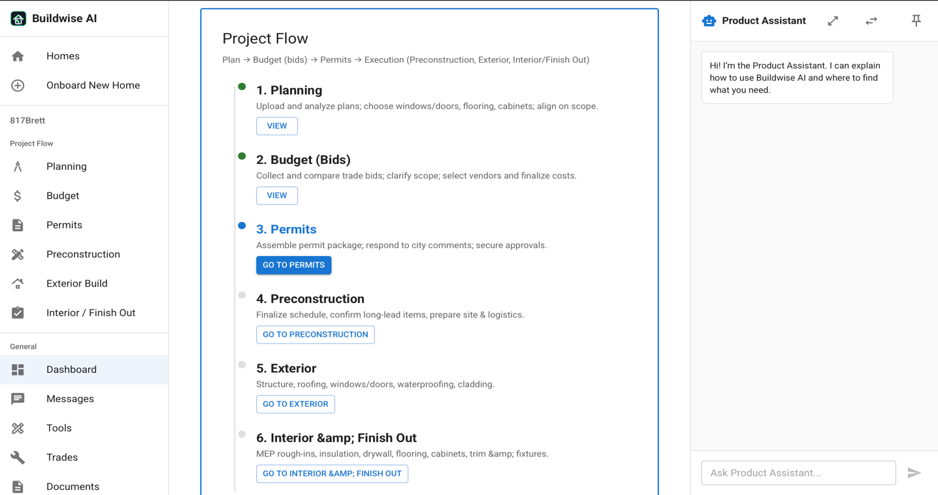

2) Knowledge Center & Multimodal Ingestion
BuildWise ingests:
- plans & blueprints (PDF)
- images and annotated markups
- trade documents
- customer requirements
Pipeline includes:
- OCR + LLM parsing
- text normalization
- structural metadata extraction
- chunking by:
  - home / project
  - trade
  - sheet / page
  - region (when coordinates exist)
These chunks feed the vector index, enabling:
- high-precision retrieval
- trade-specific context targeting
- source-aware reasoning

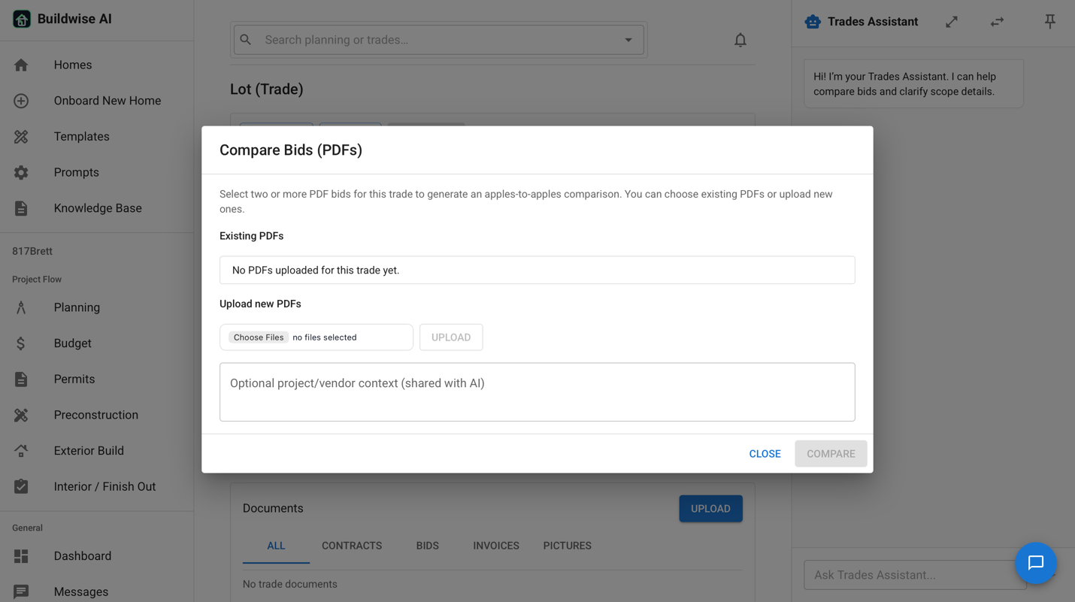

3) Structured RAG Responses
When a user asks a question or runs an analysis:
- Relevant chunks are retrieved
- Context is packed with sources
- The LLM returns strict JSON including:
- answer summary
- comparison tables
- option cards
- follow-up actions
- citations & document references
This supports:
- explainable decisions
- repeatable workflows
- auditable rationale

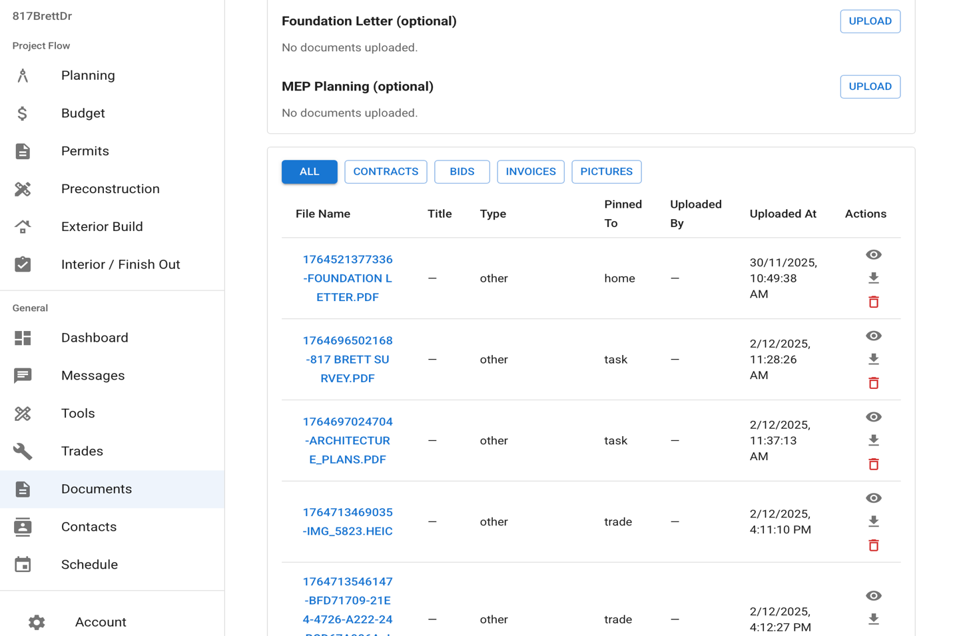

4) Plan Analysis + Requirements Fusion
BuildWise fuses:
- plan analysis results
- customer-stated requirements
- trade logic & domain knowledge
Examples:
- room & area detection
- trade planning (HVAC zones / tonnage ranges)
- capacity guidance
- cost band estimation
- recommended configuration options
Outputs are packaged as:
- structured planning summary
- per-trade breakdown
- cost & execution guidance

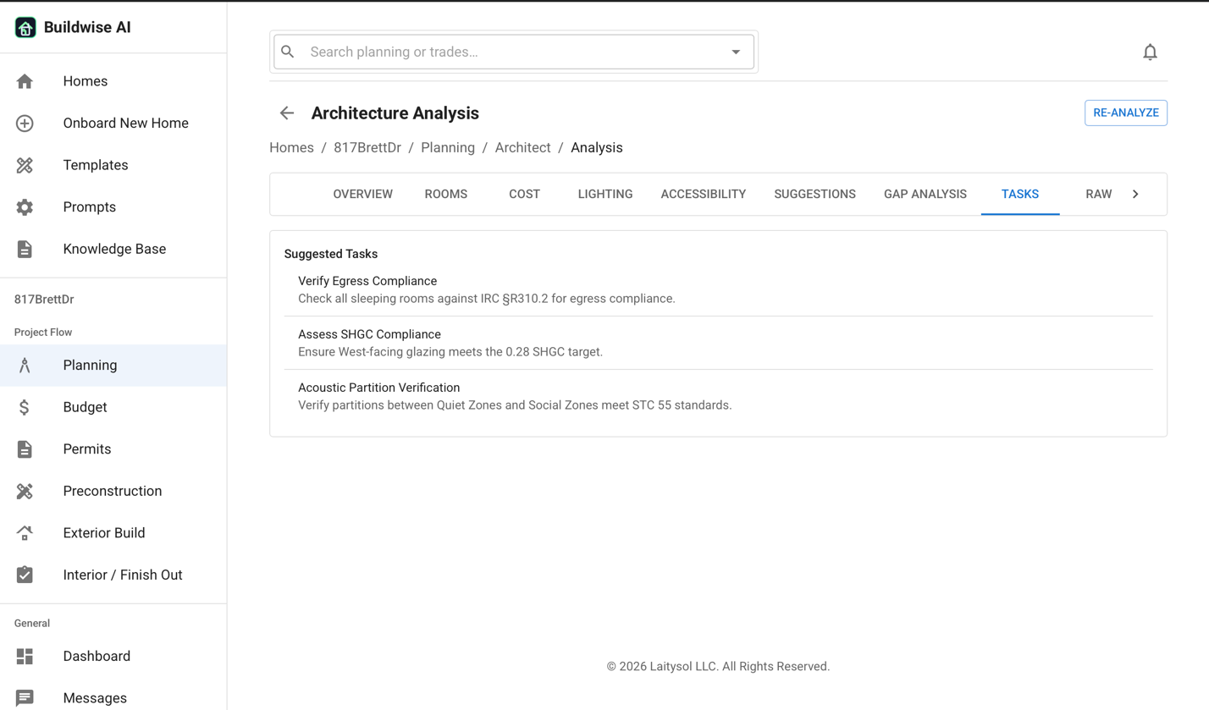

5) Rich Structured Chat + Workflow UI
The chat experience renders structured AI outputs, including:
- comparison tables
- option cards (pros / cons / attributes / ranges)
- follow-up prompts as action chips
- planning → budgeting workflow transitions
Users can:
- refine decisions
- branch scenarios
- attach docs & plans
- move outputs into budgeting
BuildWise functions as a:
Planning + Knowledge + Structured Decision AI layer for construction workflows

🌆 Nexsense — Smart-City Digital Twin & Vision AI Intelligence Platform
Nexsense is a smart-city operations intelligence platform combining:
- Vision AI
- IoT & sensor telemetry
- crowd & traffic analytics
- incident detection & correlation
- AI-assisted operator workflows
Where BuildWise focuses on plan intelligence,
Nexsense focuses on city & infrastructure intelligence.

1) Smart-City Data Fusion Core
Nexsense ingests:
- camera snapshots & detections
- incident clips
- IoT telemetry streams
- asset & zone metadata
- historical event logs
Data is normalized into:
- assets
- zones
- cameras
- events
- time-series traces
This powers:
- real-time situational awareness
- correlation analysis
- temporal pattern discovery

2) Vision AI Capabilities
Nexsense applies Vision AI for:
- crowd density estimation
- queue & congestion analytics
- pedestrian–vehicle interaction awareness
- risk-zone monitoring
- near-miss event detection
- safety hazard indicators
Outputs include:
- event type
- confidence score
- affected assets / zones
- severity level
- recommended operator actions

3) GenAI-Driven Incident Intelligence
GenAI analyzes and contextualizes events:
- explains what happened
- correlates across cameras + sensors
- identifies contributing factors
- recommends operational response paths
Structured outputs include:
- incident summary
- impacted locations / assets
- safety implications
- escalation recommendations
- source references (logs / detections / images)
This helps operators move from:
raw alerts → actionable understanding

4) Timeline Replay & Historical Insight
Nexsense supports:
- event history timeline
- back-in-time navigation
- cross-sensor playback
- incident evolution tracking
Use cases:
- crowd movement reconstruction
- operations audit review
- safety & risk analysis
- “what changed over time” diagnostics

5) Operator-Focused AI UX
Outputs render as:
- structured incident summaries
- risk scoring cards
- correlation insight panels
- recommended playbooks
- one-click follow-up actions
The platform enables:
- faster response
- clearer decision-making
- safer operational outcomes

Loopway Positioning
Together, BuildWise and Nexsense demonstrate Loopway’s expertise in:
- applied AI system design
- structured output engineering
- multimodal reasoning
- RAG & context fusion
- Vision AI + GenAI orchestration
- workflow-embedded intelligence
- enterprise-grade observability & guardrails
Loopway is positioned as:
an expert partner for designing, implementing, and operationalizing AI systems — not prototypes — but real, production-ready platforms.

